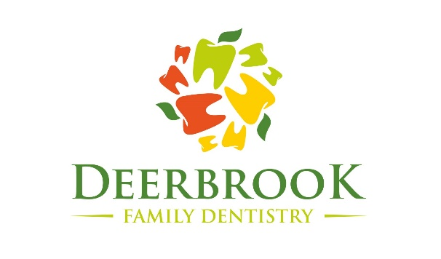
COVID-19 Pandemic Dental Treatment Consent Form

I, _______________________________________, knowingly and willingly consent to have dental treatment completed during the COVID-19 pandemic.
I understand the COVID-19 virus has a long incubation period during which carriers of the virus may not show symptoms and still be highly contagious. It is impossible to determine who has it and who does not given the current limits in virus testing.
Dental procedures create water spray. It is unclear as to how long the ultra-fine nature of the spray may linger in the air, which can transmit the COVID-19 virus.
I confirm that I am not presenting any of the following symptoms of COVOID-19 listed below:
- Fever
- Shortness of Breath
- Loss of Sense of Taste or Smell
- Dry Cough
- Runny Nose
- Sore Throat
- ___________ (Initial)

I understand that air travel significantly increases my risk of contracting and transmitting the COVID-19 virus. And the CDC recommends social distancing of at least 6 feet for a period of 14 days to anyone who has, and this is not possible with dentistry. ___________ (Initial)
- I verify that I have not traveled outside the United States in the past 14 days to countries that have been affected by COVID-19. ___________ (Initial)
- I verify that I have not traveled domestically within the United States by commercial airline, bus, or train within the past 14 days. __________(Initial)

Name____________________________________ Date____________________

